1. In Jsx we use className, htmlFor is used because Jsx is translate to Js and then they are converted to class, for.
2. It’s must to put closing slash in the self-closing tags.
3. We use onClick and onMouseOver as event listeners.
4. We don’t use if else statement in Jsx. In JSX, we **cannot** use if-else directly because JSX allows **expressions** inside {} but **not statements** like if-else.

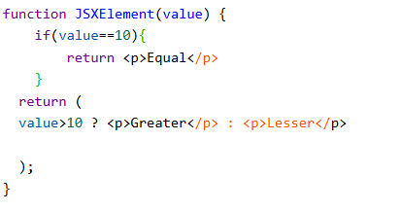

1. 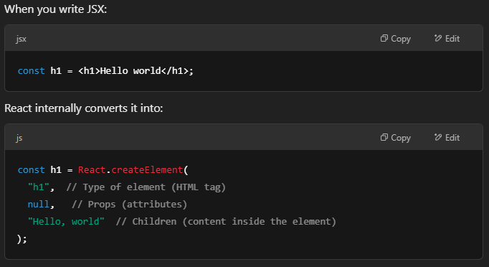
2. 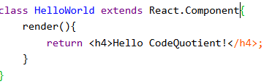 Making and Rendering a component